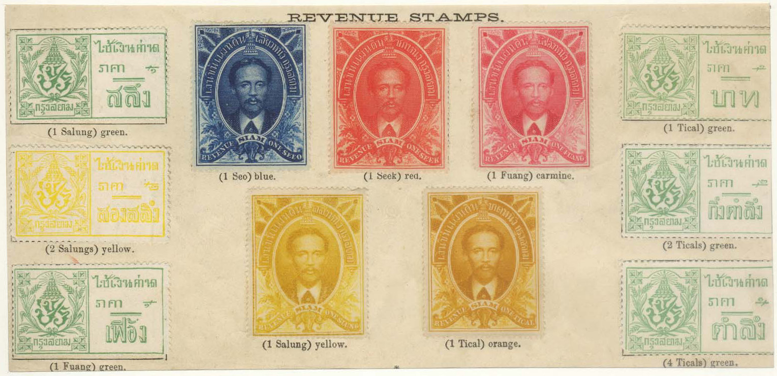
Plate V from the POSTAL ORGANIZATION OF THE KINGDOM OF SIAM, edited by the Siamese Legation in Paris by order of HRH Prince Prisdang, Postmaster General. The plate shows the first issue Court and Land Fee Revenue set plus the 6 values of the first Agriculture set. Note, there was no 2 salung value in the green set, so a yellow stamp was substituted.

CONTENTS

INTRODUCTION:

This Thailand Revenue Stamp Catalog edition 2027 written and edited by Jos Sanders is a continuation of the Thai Revenue Stamp Checklist 2019, edition eight, which was written by Richard Blakeney and Jos Sanders. Richard Blakeney passed away in Bangkok in July 2019. To continue Richard Blakeney’s legacy as the originator of the Revenue Handbook, I have decided to update the 2019 edition, a job in the making during the past eight years. The result is the Thai Revenue Stamp Catalog edition 2027.

Changes in the 2027 Revenue Catalog versus the 2019 Stamp checklist.

- Part 14a of the beverage tax stamps in the 2019 edition is now split in 3 sections, Non-alcoholic Beverages Imported alcohol and Domestic produced Alcohol.
- Part 14, Charity and Cinderella stamps in the 2019 edition is not longer in the 2027 edition. The non updated Part 14 is still posted on my website in My Catalog. Website: www.thailandrevenues.com
- Each Chapter in the 2027 edition now is as much as possible in chronological order because of the chronological order and the addition of newly discovered stamps, the numbering system is completely changed.
- The numbering system is simplified, what makes it easier to find stamps back in each Chapter.
- The stamp numbers in red color are newly added compared to the 2019 edition.
- Lots of new color pictures are added to help in identifying stamps
- In the 2027 edition stamps are priced. A – indicates that that stamp is not known to exist either in mint or in used condition. This is the first time that the stamps are priced. The market for revenue stamps is quite illiquid and prices can swing. I am happy to receive your feed-back for consideration in future editions of the Revenue Stamp Catalog.
- Prices are given in Thai baht B. In October 2026, the exchange rate was US$ 1 = baht 33

Acknowledgements: There are many collectors who have contributed pictures and suggestions over the past years. Without naming them, I like to give my sincere thanks to all of them.

The writer and editor of the 2027 Thailand Revenue Stamp catalog is a long-time resident in Bangkok Thailand. He collects Thailand revenue stamps for more than 35 years. He has written some 12 articles on Thai revenue related philatelic subjects, published mainly in the Thai Times and in The Revenue Journal. Since 2024, he maintains his own website with postings of Blogs, this 2027 catalog and his complete own collection, In addition there are postings of most Thailand Revenue exhibits over the years, literature on Thai revenues and lots more.
The website can be found at www.thailandrevenues.com
Thanks so much and enjoy this updated, priced Thai Revenue Stamp Catalog

Jos Sanders
Bangkok Thailand

