Head/Poll tax for Chinese in the Spanish colonies around 1860

The Philippines are inhabited by two distinct races of people, the Malays, who make up the bulk of the population, and the Negritos or Negrillos, who live on only five islands (Luzon, Negros, Panay, Mindore, and Mindanao), in the inaccessible parts of the islands live. The total population of the archipelago is over 5 million people, or about half the population of the only island of Java. Of these, 2000 are Spaniards and other Europeans, 5000 Creoles (descendants of parents born in Spain), 4,880,000 Malays (Tagalen, Ilocos, Pampangas, Pangasinans, Cagaya and Bicol), 25,000 Mestizos (mixtures of Spaniards and Malays), 25,000 Negritos and 65,000 Chinese and Chinese mestizos. The Malays are socially divided from the Spaniards into two classes, the civilized inhabitants of the coast, plains and valleys (belonging to six different races) and the aborigines, who inhabit the mountains and valleys in the interior, and no less than 15 different idomes to speak. The total population of the island of Luzon is approximately 2,650,000 inhabitants, including only 500 Spaniards and other Europeans. Luzon is divided into three major sections, Costa, Contra Costa and Centro, designations synonymous with western side, eastern side and centre, dating back to the time when these different parts of the island were successively brought under Spanish rule became. The latest division is into 35 provinces and 12 districts.

Governing power over the whole Archipelago, including the Mariana Islands, rests in the hands of the Governor or Generalcapitan (Capitan Generale), who combines in his person all civil and military power. If we add that the other persons who more or less take part in the administration are the archbishop and the bishops, the intendant of the army and finances, the prosecutor at the criminal court and the president of the chamber of accounts, then the picture is the absolutist government of the Philippines fairly completely.

Local chiefs were involved in a kind of indirect rule in the proselytizing and administration of the Philippine colony. From them emerged the so-called principalía, a rural native leadership class with corresponding privileges. The colony's Spanish elite preferred to remain in Manila, leaving much of the rural administration to the local principalía and local Spanish priests and monks. Most of the time, the Spanish clergy were the only Spaniards who understood the native languages, and unlike the Spanish colonial officials, they mostly spent their whole lives in the Philippines. There were also a few Spanish colonial officials who governed the provinces through the local principalía.
Lands, called encomiendas, were given to Spanish soldiers and sailors, and the local population, with the exception of the principalía, who could buy their ransom, were obliged to do compulsory labor for the encomenderos.
In addition, the locals were burdened with paying taxes to the encomenderos.
These taxes were usually collected by Spanish clergymen, the principalía or local Spanish officials.
However, the most important source of income for Spain was the role of the Philippines as a trading station between China and Mexico.
The Philippines was administered as a province of New Spain until Mexican independence in 1821.
Due to the mercantilist organized galleon trade between Manila and Acapulco, which started in 1565 and ended in 1813, many Chinese came to Manila as traders.
Through the galleon trade and the administrative assignment of the Philippines to the viceroyalty of New Spain, there were also close ties to Mexico.
The galleons, which ran once a year, brought mostly silver bars and coins from Mexico, while on the return trip Chinese goods, mainly silk and other textiles, were taken to Mexico. About 50 tons of silver were shipped from Acapulco to Manila each year, making their way to China as payment for Chinese goods.
For this reason, the galleons were often attacked by English and Dutch privateers, sometimes successfully hijacked.
The sheer volume of the galleon trade made Mexican silver pesos the de facto currency in China. In 1750 the silver surplus in China led to inflation and a devaluation of silver.

The thoroughbred Chinese are divided into three classes with respect to the poll tax, according to their social position, namely, the lowest poll tax they pay is 7 Spanish piasters, while it exceeds on average 17 piasters or dollars, so that the taxation of the thoroughbred Chinese is seventeen times as high as that of the Tagals.

Exempt from the poll tax are all Spaniards and their descendants, all foreign residents except the Chinese, all natives over the age of sixty, the descendants of some Tagal families on account of certain services rendered by their ancestors to the Spanish government, and finally the temporary native district officers (Gobernadoreillos) for the duration of their office (usually 6 years). The number of natives presently subject to a poll tax is estimated at 700,000 individuals).

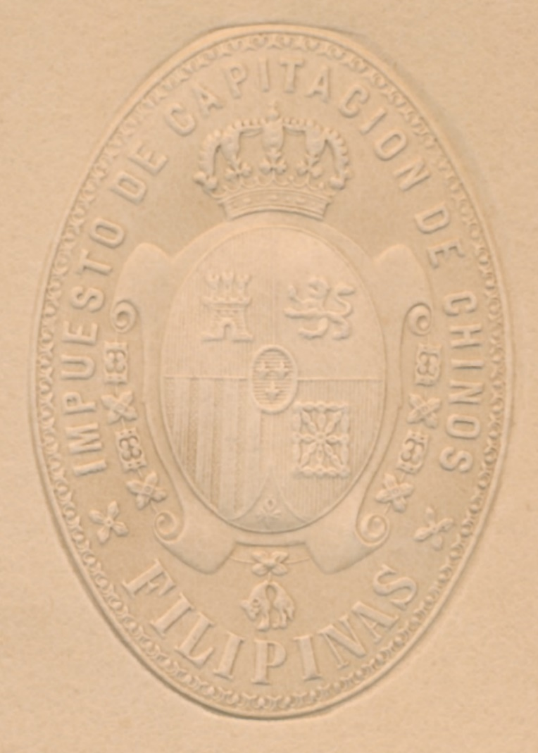
Papel Sellado 1860
Inscription: IMPUESTO DE CAPITACION DE CHINOS- FILIPINAS =
TAX OF CAPITATION OF CHINESE- PHILIPPINES

the Tax = impuesto, cuota, contribución, derechos, timón, volante, gobernalle, tasa, tasación,
the Levy = venta, gabela, derecho, tributo, desprendimiento, impuesto
the Fee = derechos, tasa, tarifa, honorarios, cuota, impuesto
the Edition = tributo, tirada, apoyo, soporte, chapado, impuesto

Source: Papel Sellado from the stamp paper pool of Gunter Wagner Filderstadt and Wolfgang Morscheck Bad Säckingen Germany. “Voyage of the Austrian frigate Novara around the world in the years 1857, 1858, 1859 under the orders of Commodore B. von Wüllerstorf-Urbair. - Statistical-commercial part. Second volume. Scherzer, Karl von, Publisher: Gerold's Sohn, Vienna, 1865

